**Energy Pyramid**

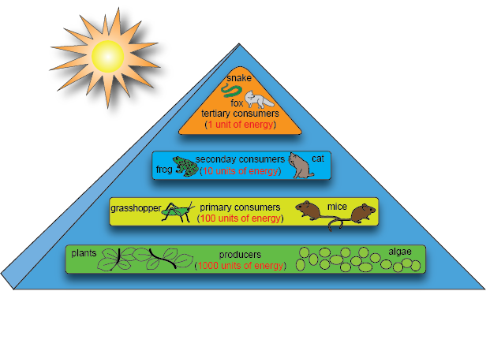

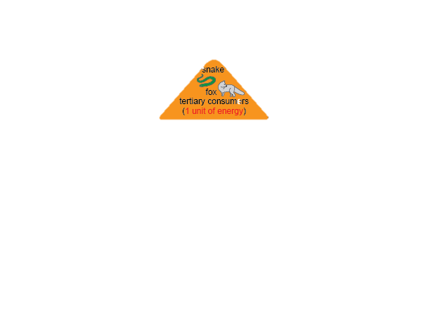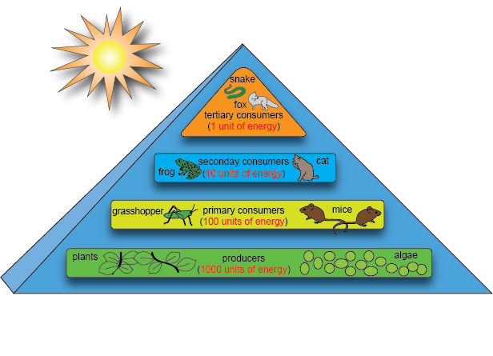

***Tertiary Consumers***

***Secondary Consumers***

***Primary Consumers***

4. The eagles eat the snake

5. When the hawks die, fungi break the bodies down and turns into nutrients.

6. The nutrients, along with sun and water, cause the grass to grow.

1. The grasshopper eats the plants
2. The mice eat the grasshoppers
3. The snake eats the mice

***Producers***





